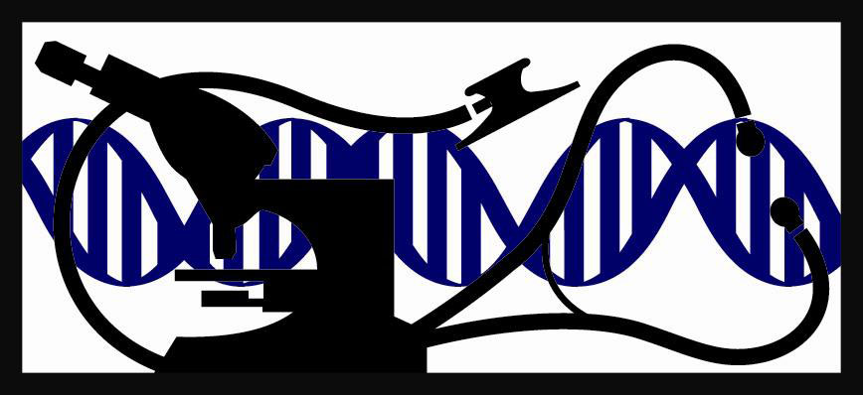

Leading Research in Human and Animal Disease

Postdoctoral Fellowship in Laboratory Animal Medicine

(Research Emphasis)

The Johns Hopkins University Department of Molecular and Comparative Pathobiology invites applications for our 4-year postdoctoral fellowship with a research emphasis. This training opportunity is comparable to postdoctoral fellowships/PhD programs offered at veterinary schools and is distinguished by the broader research opportunities afforded by a large medical institution and the opportunity to pursue a PhD in a JHU graduate program. This is a 2-part program: three years of research training, funded by the National Institutes of Health, preceded by 1 year of clinical rotations funded by Research Animal Resources. The program prepares candidates for certification by the American College of Laboratory Animal Medicine (ACLAM).

Program
During the first year, postdoctoral fellows gain comprehensive experience in clinical care and diagnostic procedures through rotations in large animal anesthesia and surgery, Old and New world non-human primate medicine and breeding colony management, rodent clinical care and herd health program management, and pathology. Didactic training includes weekly lectures to cover boards-relevant materials, journal club, pathology slide conference, a special topics seminar series and seminars on animal behavior. In years 2 to 4 trainees participate in full-time mentored basic or translational research in a discipline of their choice. Postdoctoral fellows may pursue a PhD concurrent with their research training, finishing their PhD after completing the lab animal fellowship.

Faculty
Our faculty includes 7 veterinarians with ACLAM and/or ACVP board certification plus additional PhD faculty. Research interests include virology, parasitology, neuropathology, immunology, surgical devices, cardiovascular disease, proteomics, RNA biology, rodent phenotyping, animal behavior, welfare and laboratory animal diseases. Postdoctoral fellows also may work with faculty from more than 30 academic departments forming Johns Hopkins Medicine.

Qualifications
This position is targeted for a veterinarian who wishes to pursue a career in research as a laboratory animal veterinarian. Candidates must have a DVM or equivalent degree, be a citizen or permanent resident of the United States who has graduated from an AVMA-accredited institution and has passed the NAVLE. Candidates from non AVMA-accredited institutions must be citizens or permanent residents of the United States and must have the ECFVG or a license to practice veterinary medicine in at least one state of the United States.

Applications
Johns Hopkins participates in the Veterinary Internship and Residency Matching Program (VIRMP) [www.virmp.org]. Applicants must submit their applications by Monday, December 13, 2021. Questions can be addressed to Emma Ey, Sr. Academic Program Coordinator, Johns Hopkins University, 733 N. Broadway, Suite 811, Baltimore, Maryland 21205, phone (443) 287-2953 or Emailed to dvmtraining@jhmi.edu. Johns Hopkins University is an equal opportunity employer and educator.

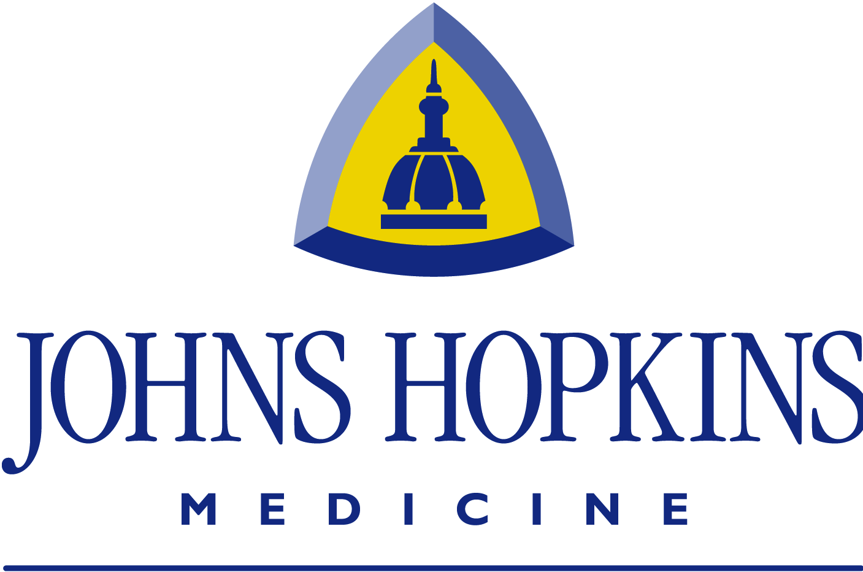

Department of Molecular and Comparative Pathobiology

